**DESIGN CHALLENGE GRANT REVIEW AND APPROVAL POLICIES AND PROCEDURES**

The Quakertown Alive Design Challenge Grant is available to commercial properties within the Program Area to stimulate private investment in downtown properties, to foster an attractive shopping environment, and to preserve Quakertown’s architectural heritage. The Program Area is the geographic area along East and West Broad Street between Route 309 and Hellertown Avenue extending two blocks north and south from Broad Street (see shaded area of map below) and commercial property adjacent thereto.

The Quakertown Historic District encompasses a majority of the incorporated Quakertown Borough. Although the borough does not have a Historic Architectural Review Board, we strongly encourage property owners to adhere to state guidelines regarding appropriate renovations for historic buildings.

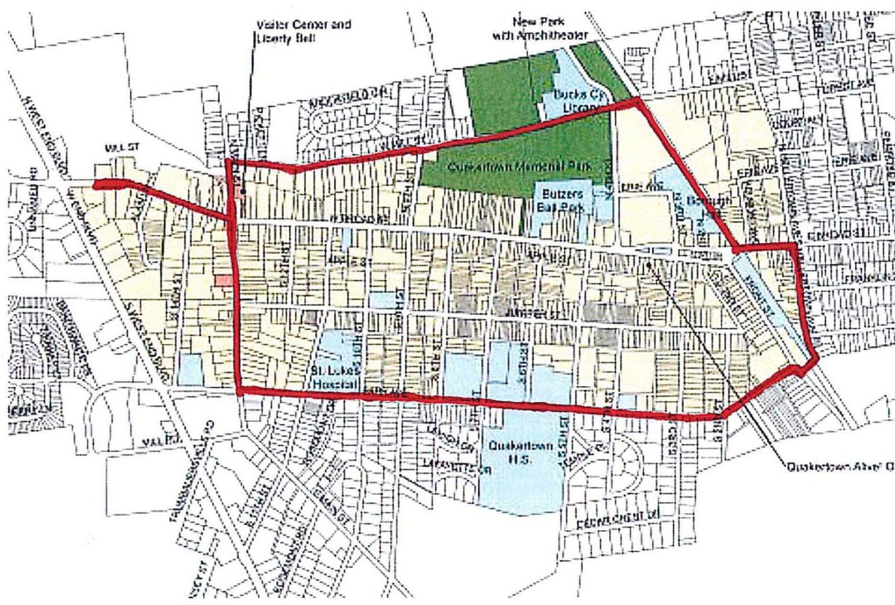

# PHASE ONE

The Program will begin accepting proposals of façade work for the year 2024/26 in a timely manner after notification of award of the grant.

The selection of Design Challenge Grant recipients is based solely on project merit and not on financial need. Only commercial properties and external improvements are eligible.

Matching Grants will be made based on approval from the Quakertown Alive! Board of Directors, appropriateness of design, impact on the program area, and order of receipt of applications.

The Quakertown Alive Design Committee will review applications and determine eligibility using the Quakertown Alive! Design Grant Criteria, and Design Grant Guidelines.

The Quakertown Alive! Board of Directors has sole discretion for approving and distributing Design Challenge Grant funds. At no time shall the Quakertown Alive! Board of Directors choose to deny releasing Design Challenge Grant funds to an applicant who has otherwise met all the obligations of, and has completed all work per the Design Challenge Grant Application.

The Design Challenge Grant Review and Approval Flowchart (attached hereto) summarizes the step-by-step procedures a person shall follow from initial inquiry to final payment.

Projects will be evaluated in terms of quality, design compatibility and level of visual impact.

Individual property owners and authorized tenants, leasees, etc… must match the Grant dollar-for- dollar with private investment monies.

Our Latino Storefront Initiative expands our reach to include our emergent community of local Latino business owners. We will be providing several smaller mini-grants totaling $1,000 to these business owners. We have found that these business owners take great pride of ownership in their businesses, but have limited resources to improve their storefronts. We feel that this important initiative will further diversify our business district adding strength and vibrancy to our downtown.

## Who is Eligible?

* A single-property owner can receive a grant up to $5,000.
* A single-property owner can receive more than one Grant if he/she owns more than one property.
* If a property owner seeks and receives a Grant, a tenant in the same building can also receive a Grant as long as the total amount does not exceed the Grant maximum.
* A tenant can apply for the full amount, with the consent of the property owner.
* Buildings that span more than one street address may be eligible for a Grant up to $3,500 or 50% of the total project cost.
* Signage up to $1,500.
* Murals approved by Borough, Quakertown Alive and property owner up to $5,000.

A joint facade improvement project (with three or more adjoining properties that share a common wall) is eligible for grants up to $3,500 per property or 50% of the total project cost whichever is less.

All work must conform to local and state ordinances: permits from the Borough of Quakertown and/or permission from the property owner will be required, if applicable.

Where applicable all work must conform to U.S. Department of the Interior’s “Standards for Rehabilitation and Guidelines for Rehabilitating Historic Buildings”.

All work must be completed in a manner consistent with the work described in the approved Design Grant application. Reimbursement will be made upon completion of the project.

The applicant must submit to the Quakertown Alive Design Committee documentation that substantiates the total and final cost of the work and documentation that substantiates the work is complete.

No more than three (3) grants will be approved per property/ business owner per year, based on the application approval date.

All work must be completed within 6 months from the grant approval date; otherwise the grant will be forfeited.

The Quakertown Alive Design Committee will stop accepting new applications upon such time as all Grant money is allocated for the year. Grant monies allocated but not distributed will be made available to additional new applicants within this same year. Newly available funds would be advertised in the newsletter since that communicates with all property owners and business operators. No one will have his or her applications rejected.

Project costs are inclusive of appropriate Pennsylvania sales taxes.

For the purposes of approving Design Challenge Grant applications, boarding houses are to be considered commercial property.

**ELIGIBLE PROJECT DESIGNS INCLUDE:**

*The following improvements, when visible from the public right-of-way, are eligible for funding* ***at the discretion of the Design Committee:***

* Exterior Doors and Windows
* Exterior Lighting
* Decorative Architectural Enhancements
* Façade Improvements
* Exterior Signage
* Exterior Paint
* Exterior Woodwork, Masonry, and Brickwork/ Pointing
* Building Restoration and Renovation
* Removal of Inappropriate Materials & Additions on Building Surface to Re-expose Original Architectural Features
* Professional Design Assistance - if project is implemented
* Awnings
* Approved Mural Designs – artist fees and supplies

**PROJECTS THAT ARE NOT ELIGIBLE:**

* Maintenance Projects
* Interior Renovations and Improvements
* Plastic Signage/ Window Decals
* Roofing or Siding Repairs
* Sidewalks, Driveways, or Parking Lot Repairs
* Landscaping
* New Building Construction

**PHASE TWO**

## Application Process

1. The Design Committee will facilitate workshop meetings for business and property owners to learn more of the grant process, discuss design improvements appropriate for a historic district, and architectural concerns and questions. Property and business owners can also arrange a pre-application meeting with Quakertown Alive!. Bring the application form, filled-out as completely as possible to the meeting.
2. Submit the following materials to complete your application:
   * Completed application form, including property owner’s signature.
   * Photographs showing the building façade prior to improvements
   * Photographs showing the building façade after improvements are complete
   * Copies of all cancelled checks (front and back) made out to contractors
   * All invoices for work. Invoices MUST include contractors’ license numbers
   * Signed sexual harassment/ non-discrimination policy agreement.
3. The Design Committee will review the completed application packets and provide feedback or accept the application.
4. The QA! Board of Directors will review the application under advisement of the Design Committee.
5. Accepted applicants will be notified by the QA! Executive Director.

# PHASE THREE

## Reimbursement Process

1. The following materials should be submitted after project completion to ensure reimbursement:
   * Photograph(s) showing entire façade from sidewalk to roof
   * Copies of final invoices, signed and marked paid – invoices MUST include contractors’ license numbers
   * Proof of payment (cancelled checks) if not previously provided
   * Written explanation of significant differences between the estimates and final invoices if applicable.

*Continued on next page….*

* All paperwork must have the address referred to on the grant application on each page and each page must be numbered.
* Please provide ***high resolution photos*** for our website and for media as we will include these façade projects in our marketing when possible.
* All work must be completed within six months from the grant approval date, otherwise the grant will be forfeited.
* The Quakertown Alive! Design committee will stop accepting new applications upon such time as all grant monies have been allocated for the year. Grant monies allocated but not distributed will be made available to additional new applicants within the same year. Newly available funds will be advertised via newsletter as that communicates with business operators and property owners.

## Contact Information

For more information, or to schedule a pre-application meeting, contact Naomi Naylor, Quakertown Alive! Executive Director, at 215-536-2273 or [info@quakertownalive.com](mailto:info@quakertownalive.com).

Rev/2024